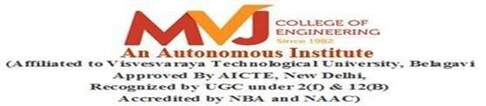

**A MINI PROJECT REPORT**

ON

**ARDUINO BARRIER SENSING MODULE**

Submitted in partial fulfillment of requirements for the award of 6th Sem of

## BACHELOR OF ENGINEERING IN

**COMPUTER SCIENCE & ENGINEERING**

Submitted By:

|  |  |
| --- | --- |
| **1MJ21CS149** | **Pavithra S** |
| **1MJ21CS171** | **Rakshitha E** |
| **1MJ21CS184** | **S Sinchana** |
| **1MJ21CS185** | **Sahana S** |

Under the Guidance of

## Mrs. P Sharmila

Assistant Professor, Department of CSE

### DEPARTMENT OF COMPUTER SCIENCE & ENGINEERING MVJ COLLEGE OF ENGINEERING

**BANGALORE-67 ACADEMIC YEAR 2023-24**

# MVJ COLLEGE OF ENGINEERING



### Near ITPB, Whitefield, Bangalore-67

**DEPARTMENT OF COMPUTER SCIENCE AND ENGINEERING**

CERTIFICATE

This is to certify that the mini- project work, entitled “**Arduino Barrier Sensing Module”** is a bonafide work carried out by PAVITHRA S(1MJ21CS149) in partial fulfillment for the award of degree of Bachelor of Engineering in Computer Science & Engineering during the academic year 2023-24. It is certified that all the corrections/suggestions indicated for Internal Assessment have been incorporated in the Report. The mini project report has been approved as it satisfies the academic requirements.

**Signature of the Guide Signature of the HOD**

**Mrs. P Sharmila Dr. Kiran Babu T S**

**Assistant Professor, Dept of CSE**

Name of examiners: Signature with date: 1.

2.



# MVJ COLLEGE OF ENGINEERING

### Whitefield, Near ITPB, Bangalore-67

**DEPARTMENT OF COMPUTER SCIENCE AND ENGINEERING**

DECLARATION

I, **PAVITHRA S** hereby declare that the entire work titled “**ARDUINO BARRIER SENSING MODULE”** embodied in this mini project report has been carried out by me during the 6th semester of BE degree at MVJCE, Bangalore under the esteemed guidance of **Mrs. P Sharmila**, Assistant Prof, Dept. of CSE, MVJCE. The work embodied in this dissertation work is original and it has not been submitted in part or full for any other degree in any University.

PAVITHRA S 1MJ21CS149

SAHANA S 1MJ21CS185

S SINCHANA 1MJ21CS184

RAKSHITHA E 1MJ 21CS171

Place: Date:

# ABSTRACT

1. This project presents a low-cost and easy-to-implement barrier sensing module using Arduino and the Ultrasonic sensor (HC-SR04).
2. The module detects barriers within a adjustable range, making it suitable for various applications such as robotics, automation, and accessibility.
3. The system utilizes the Ultrasonic sensor to emit and receive ultrasonic waves, calculating distance and detecting barriers.
4. The Arduino board processes the sensor data, triggering an LED indication when an obstacle is present.
5. The module offers non-contact sensing, easy integration with Arduino, and adjustable detection range.
6. Its simplicity and low cost make it an ideal solution for various projects and applications.
7. This project demonstrates a reliable and efficient barrier sensing system, paving the way for further developments and integrations in various fields.

i

# ACKNOWLEDGEMENT

The satisfaction and euphoria that accompany a successful completion of any task would be incomplete without the mention of people who made it possible, success is the epitome of hard work and perseverance, but steadfast of all is encouraging guidance.

So, with gratitude we acknowledge all those whose guidance and encouragement served as beacon of light and crowned our effort with success.

We are thankful to Dr. Suresh Babu V, Principal of MVJCE for his encouragement and support throughout the project work.

We are thankful to Dr. Brindha M, Vice-Principal of MVJCE for her encouragement and support throughout the project work.

We are thankful to Mr. Kumar, Controller Of Examinations for his encouragement and support throughout the project work.

We are also thankful to Dr. Kiran Babu T S, HOD, CSE Department for his incessant encouragement & all the help during the project work.

We consider it a privilege and honor to express our sincere gratitude to our guide Mrs. P Sharmila, Assistant Professor, CSE Department for her valuable guidance throughout the tenure of this project work, and whose support and encouragement made this work possible.

It is also an immense pleasure to express our deepest gratitude to all faculty members of our

department for their cooperation and constructive criticism offered, which helped us a lot during our project work.

Finally, we would like to thank all our family members and friends whose encouragement and support was invaluable.

Thanking You

# TABLE OF CONTENTS

Abstract i

Acknowledgement ii

Table of content iii

List of Figures iv

CHAPTER 1: INTRODUCTION 01

CHAPTER 2: LITERATURE SURVEY 02-06

CHAPTER 3: PROBLEM ANALYSIS 07

CHAPTER 4: EXISTING AND PROPOSED SYSTEM 08-09

CHAPTER 5: HARDWARE AND SOFTWARE REQUIREMENTS 10

CHAPTER 6: IMPLEMENTATION 11-14

CHAPTER 7: RESULTS 14-22

CHAPTER 8: APPLICATIONS 23

CHAPTER 9: ADVANTAGES AND DISADVANTAGES 24-25

CONCLUSION 26

FUTURE ASPECTS 27

REFERENCES 28

# LIST OF FIGURES

1. System Architecture 10
2. Flow Diagram 13
3. Home page 14
4. Searching Visualizer 15
5. Sorting Visualizer 16
6. BFS Detail 17
7. DFS Detail 18
8. Bubble Sort Detail 19
9. Insertion Sort Detail 20
10. Selection Sort Detail 21
11. Info Page 22

**CHAPTER 1**

# INTRODUCTION

The Arduino Barrier Sensing Module is a innovative solution for detecting obstacles and barriers in various environments. This module utilizes the popular Arduino platform and the Ultrasonic sensor (HC-SR04) to create a non-contact sensing system. The module is designed to be easy to use, affordable, and highly customizable, making it an ideal solution for a wide range of applications, including:

1. Robotics and autonomous vehicles
2. Industrial automation and control
3. Accessibility and assistive technology
4. Home automation and security systems

The Arduino Barrier Sensing Module offers a reliable and efficient way to detect obstacles, allowing for:

1. Precise distance measurement
2. Adjustable detection range
3. Non-contact sensing, reducing wear and tear
4. Easy integration with Arduino boards and other sensors
5. Low cost and simplicity, making it accessible to hobbyists and professionals alike

This module has the potential to revolutionize the way we interact with and navigate our environment, enabling the creation of smarter, more efficient, and more accessible systems.

**CHAPTER 2**

# LITERATURE SURVEY

## PAPER 1: Automatic movable road divider using Arduino UNO with Node Micro Controller Unit (MCU)

**AUTHORS: S. Sai Sri Vastava,** **B.Vandana**

**PUBLISHED ON: 2023**

The most popular microcontroller, Arduino is gaining interest for prototyping and optimizing instruments.The use of Arduino as a standalone instrument to measure cell barrier integrity.

It aim to reduce Cost-Effectiveness, Ease of Use and Arduino platforms are highly customizable.

Arduino platforms may not provide the same level of accuracy and precision as commercial TEER measurement systems.

Arduino-based sensors for measuring TEER is dynamic and multifaceted, encompassing advancements in technology, methodology, applications, and educational outreach.

## PAPER 2: Automatic movable road divider using Arduino UNO with Node Micro Controller Unit (MCU)

**AUTHORS: Ahmad Supli, Syamsul Bahrin Zaibon, Norshuhada Shiratuddin PUBLISHED ON: 2023**

This implication of widening the existing roads or building new one by acquiring the space just results in increase of additional heavy traffic.

Arduino Uno and Node MCU boards are relatively inexpensive and Arduino Uno and Node MCU platforms are user-friendly.

Processing Power, Reliability in Industrial Environments , Communication Range and Stability.

Automatic movable road divider systems using Arduino Uno with Node MCU can continue to evolve as intelligent, adaptive, and sustainable solutions for enhancing road safety.

## PAPER 3: Maze solving robot with automated obstacle avoidance

**AUTHORS: Sweta Bansal, Karan Kohli, Krishna Kumar Vishwakarma, Kush Gupta.**

## PUBLISHED ON: 2016

## The maze solving vehicle is designed with three infrared sensors of two is used for wall detection to avoid colloision and third is for obstacle detection .

## In this design, accuracy of measurements and the real-time processing allied with minimum processing power.

## The structure would able to correct its orientation errors arising its physical motion within the maze only.

## Improvization can be done based on solving capability of robot’s maze in a bigger and more complex maze with reconfigurable figure.

## PAPER 4: Neural control system in obstacle avoidance in mobile robots using ultrasonic sensors

**AUTHORS: Sweta Bansal, Karan Kohli, Krishna Kumar Vishwakarma, Kush Gupta.**

## PUBLISHED ON: 2014

## This section describes the robot structure analysis, engine capabilities used, housing the brain neural networks sensor system, Arduino embedded platform is used to implement the neural control for field results.

## Neural networks are excellent tools applicable in mobile robots evading obstacles,which have the ability to work with imprecise information.

## Edge detection is need of the robot to stop infront of an obstacle in order to provide more accurate measurement.

## Further research suggested to integrate a SRF08 series that offers better supervision ease collbration, and the size than the SRF08 series.

## PAPER 5: Real -Time obstacle avoidance for humanoid- controlled mobile platform navigation

**AUTHORS: Sweta Bansal, Karan Kohli, Krishna Kumar Vishwakarma, Kush Gupta.**

## PUBLISHED ON: 2016

## The mobile platform was tested in indoor environment to measure the performance and maneuverability based on steering turning angle capability and the speed. The system integration between NAO and the mobile platform is done through using Arduino microcontrollers and NAO humanoid robots are used because they act versatile. It is difficult when two obstacle avoidance one after the other it is unable to handle. For future work, we can include path planning to improve the overall navigation to detect the obstacle in given environment.

## PAPER 6: Intelligent Tracking obstacle avoidance wheel robot based on arduino

**AUTHORS: Sweta Bansal, Karan Kohli, Krishna Kumar Vishwakarma, Kush Gupta.**

## PUBLISHED ON: 2016

## This paper uses Arduino as the core control system, combined with infrared tracking module. Four modules such as ultrasonic obstacle avoidance module, motor drive module and power module. Wheeled robot capable of intelligent tracking, obstacle detection and improving safety. It also provides feasibility and verification for realization of unmanned intelligence. In the process of tracking the intelligent wheel type robot, if running speed of car is too high, the car may not be able to adjust the direction. This system will have very important significance and reference value for the future research and industrialization of smart cars.

## PAPER 7: Development of air conditional route wireless inspection robot.

**AUTHORS: Sweta Bansal, Karan Kohli, Krishna Kumar Vishwakarma, Kush Gupta.**

## PUBLISHED ON: 2012

## The movement and speed of the wireless inspection robot can be controlled remotely by using a joystick. This robot also can be used to detect a leaking hole based on heat detection and clean the air conditioning route. This user friendly wireless inspection robot is expected to overcome the inspecting and cleaning the air conditional route problem in the fastest and easiest way. Due to the small air conditioner routes it is difficult to human to inspect these air conditional routes. Wireless inspection robot operation include reduce number of workers and the able to access unreachable areas by humans.

## PAPER 8: Sensor based mobile navigation using humanoid robot nao.

**AUTHORS: Sweta Bansal, Karan Kohli, Krishna Kumar Vishwakarma, Kush Gupta.**

## PUBLISHED ON: 2015

## This project presents a new approach of humanoid-operative 4-wheeled mobile platform. Its wide range of movements allows it to perform various tasks such as steering through a simple programming algorithm. The implementation of sensing system in the mobile platform shows very good result as the platform able to avoid obstacles while navigating. The detection using infrared sensor is not enough as detection area is limited to one straight line detection. The usage of laser range sensor can be considered in future to provide better detection.

## PAPER 9: AirQo sensor kit

**AUTHORS: Albin Thomas, Ashutosh Singh Yadav, Ayush Soni, Chaman Mandloi, Pir Mohammad**

## PUBLISHED ON: 2023

## Air pollution remains a major public health risk. People living in urban spaces are among those most affected by exposure to unhealthy levels of air pollution. Affordability, Real-Time Monitoring and Integration with Data Analytics Platforms. Accuracy and Calibration, Sensor Drift and Stability and Limited Measurement Range. The AirQo sensor kit for low-resource settings encompasses advancements in sensor technology, multi-pollutant monitoring, remote sensing.

## PAPER 10: Smart real time health monitoring system using Arduino and raspberry Pi

**AUTHORS: Albin Thomas, Ashutosh Singh Yadav, Ayush Soni, Chaman Mandloi, Pir Mohammad**

## PUBLISHED ON: 2021

## This work proposes a design of a health care monitoring system by using Arduino and Raspberry PI, to monitor the parameters i.e., heartbeat, body temperature, heart rhythm, and electrical activity.

## Flexibility, Customizability, Rich Sensor Ecosystem and Cost-Effective Solution.

## The accuracy and reliability of health monitoring measurements may be affected by the quality and calibration of sensors, as well as variations in environmental conditions.

## Smart real-time health monitoring systems using Arduino and Raspberry Pi is characterized by innovation, collaboration, and empowerment, with the potential to revolutionize healthcare delivery, improve health outcomes etc.

**CHAPTER 3**

# PROBLEM ANALYSIS

The Arduino barrier sensing module aims to detect obstacles and alert users through visual and auditory signals. The module should be able to detect obstacles within a range of 1-100 cm and provide a clear and visible indication of the obstacle through LED lights. Additionally, it should produce an audible alert through a buzzer or speaker to ensure users are aware of the obstacle.

The module must operate on a low-power consumption mode to ensure long battery life, making it suitable for applications where power is limited. Furthermore, the module should be compact and easy to integrate into various applications, such as robotics, home automation, or accessibility devices.

The development of the module is constrained by the need to use only Arduino-compatible components and libraries. The module's size and weight must also be kept minimal to ensure ease of integration. Moreover, the module's accuracy and reliability in detecting obstacles are crucial to ensure user safety and trust.

The goals of the project are to develop a reliable and accurate barrier sensing module, create a user-friendly and intuitive alert system, optimize power consumption for extended battery life, and design a compact and versatile module for various applications. By achieving these goals, the Arduino barrier sensing module can provide a valuable solution for various industries and applications.

**CHAPTER 4**

# EXISTING SYSTEM

The existing system of an Arduino barrier sensing module project typically involves the use of various components to detect obstacles or barriers and provide feedback to the user. Motor driver: It helps to control the motor attached to the robot, it is connected to ardunio. The ultrasonic sensor senses any obstacle in front of the robot. Servo motor helps the robot to sense obstacles in the left and right direction.

### DISADVANTAGES OF THE EXISTING SYSTEM

**Limited Range:** Some sensors, like IR sensors, have a limited range (typically up to 4-5 meters) and may not be effective for longer distances

**Interference:** Ultrasonic sensors can be affected by ambient noise, while IR sensors can be affected by bright light or reflective surfaces.

**False Triggers:** Capacitive sensors can be triggered by non-metallic objects or environmental factors like humidity.

**Power Consumption:** Some sensors, like ultrasonic sensors, may consume more power than others, affecting battery life in portable projects.

**Complexity:** Laser-based sensors can be more complex to integrate and require additional processing power

**PROPOSED SYSTEM**

In the proposed system, we use ultrasonic sensors or infrared sensors to detect the presence of a barrier. The Arduino would then process the sensor data and output a signal based on whether a barrier is present. This system could be used in a variety of applications, such as robotics, automated guided vehicles, or security systems.

### ADVANTAGES OF PROPOSED SYSTEM:

**Non-Contact Sensing:** Detects obstacles without physical contact, reducing wear and tear.

**Easy Integration:** Compatible with various Arduino boards and sensors, making it easy to integrate into projects.

**Adjustable Range:** Adjustable detection range (1 cm to 200 cm) to suit different applications.

**Low Cost:** Affordable and cost-effective solution for obstacle detection.

**High Accuracy:** Accurate distance measurement (± 1 cm) for reliable obstacle detection.

**Fast Response Time:** Quick response time (< 50 ms) for timely obstacle detection.

**CHAPTER 5**

# HARDWARE AND SOFTWARE REQUIREMENTS

* 1. **Hardware Requirements:**

1. **Arduino UNO Board**

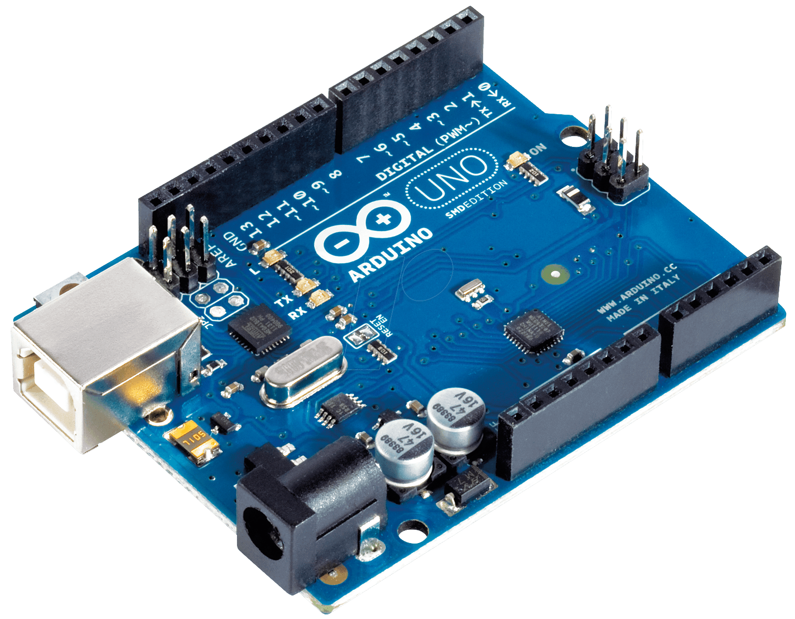

1. Microcontroller: The Arduino Uno is based on the ATmega328P microcontroller.

2. Input/Output: The board has 14 digital input/output pins, 6 analog input pins, and 16 megabytes of flash memory.

3. Communication: The Uno supports serial communication through USB or serial pins.

4. Power: The board can be powered via USB or an external power supply (7-12V).

5. Reset button: The Uno has a reset button to restart the program.

6. LED indicators: The board has built-in LED indicators for power, TX, and RX.

7. Shield compatibility: The Uno is compatible with a wide range of Arduino shields.

8. Dimensions: The board measures 68.6 mm x 53.4 mm (2.7 in x 2.1 in).

9. Weight: The Uno weighs approximately 25 grams (0.88 oz).

10. Operating voltage: The board operates at 5V, with a maximum current of 500 mA.

11. Programming: The Uno is programmable using the Arduino IDE software.

12. Bootloader: The board comes with a pre-installed bootloader for easy programming.

The Arduino Uno is a popular and versatile board, ideal for beginners and experienced makers alike, and is widely used in various projects, from simple circuits to complex robots.

1. **HCSR04 range sensor**

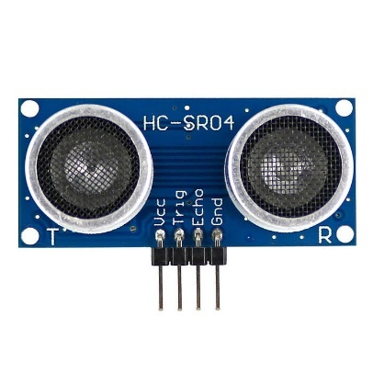

Ultrasonic sensors are devices that use high-frequency sound waves to measure distance, proximity, or detect objects. Here are some key points about ultrasonic sensors:

How they work:

1. Transmitting: The sensor sends out ultrasonic sound waves.

2. Reflecting: The sound waves bounce off an object and return to the sensor.

3. Receiving: The sensor measures the time-of-flight or frequency shift to calculate distance.

Types of ultrasonic sensors:

1. Contactless sensors: Measure distance without physical contact.

2. Proximity sensors: Detect presence or absence of objects.

3. Distance sensors: Measure exact distances.

Characteristics:

1. Frequency: Typically operate between 20 kHz to 200 kHz.

2. Range: Varying detection ranges, from a few centimeters to several meters.

3. Accuracy: High accuracy, often within 1-2% of measured distance.

4. Resolution: Ability to detect small changes in distance.

1. **Breadboards**

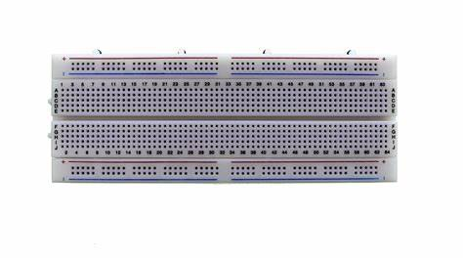

Breadboards are versatile tools for prototyping and testing electronic circuits. Here are some key points about breadboards:

What is a breadboard?

A breadboard is a rectangular board with a grid of holes and connectors, used for building and testing electronic circuits.

Key features:

1. Grid pattern: Holes are arranged in a grid, making it easy to connect components.

2. Connectors: Metal strips connect holes in rows, allowing for easy component connection.

3. No soldering: Components can be inserted and removed without soldering.

4. Reusable: Breadboards can be reused multiple times.

Types of breadboards:

1. Full-size breadboard: Standard size, approximately 8.5 x 5.5 inches.

2. Half-size breadboard: Smaller version, approximately 4.5 x 3.5 inches.

3. Mini breadboard: Compact version, approximately 2 x 1.5 inches.

4. Breadboard modules: Specialized boards for specific components, like Arduino or Raspberry Pi.

Using a breadboard:

1. Plan your circuit: Sketch your circuit before building.

2. Insert components: Carefully insert components into the grid.

3. Connect components: Use jumper wires to connect components.

4. Test your circuit: Verify your circuit works as expected.

1. **Jumper Wires**

Jumper wires are flexible electrical wires used to connect components on a breadboard or other electronic projects. Here are some key points about jumper wires:

Types of jumper wires:

1. Male-male jumper wires: Connect male headers to male headers.

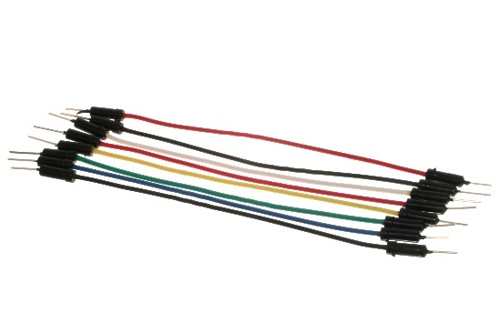

1. Male-female jumper wires: Connect male headers to female headers.

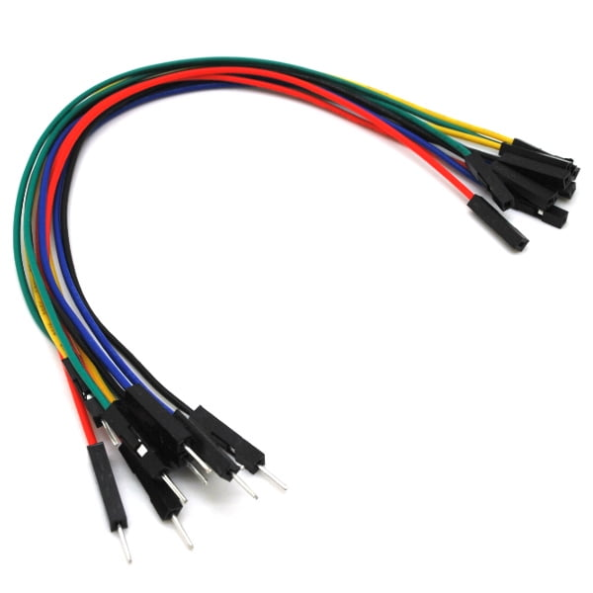

1. Female-female jumper wires: Connect female headers to female headers.

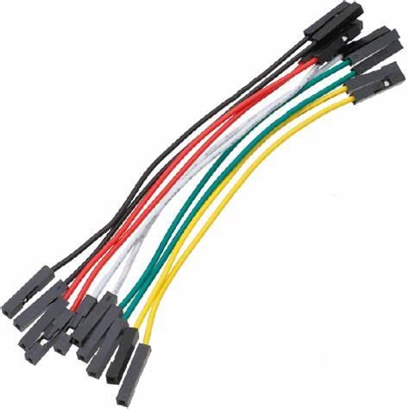

Characteristics:

1. Length: Varying lengths, typically 5-20 cm (2-8 inches).

2. Color-coding: Often color-coded for easy identification.

3. Insulation: Typically PVC or silicone-insulated.

4. Conductor: Copper or aluminum wire.

Uses:

1. Breadboard connections: Connect components on a breadboard.

2. Component connections: Connect components to each other.

3. Power connections: Connect power sources to components.

4. Signal connections: Connect signals between components.

1. **Led Lights**

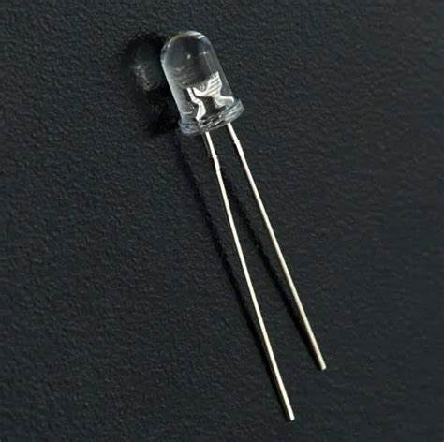

LED (Light Emitting Diode) lights are a popular choice for various applications due to their energy efficiency, long lifespan, and design flexibility. Here are some key points about LED lights:

Types of LED lights:

1. Standard LEDs: General-purpose LEDs for indicator lights, backlighting, and basic illumination.

2. High-Power LEDs: Brighter LEDs for task lighting, spotlights, and outdoor applications.

3. RGB LEDs: Color-changing LEDs for decorative lighting, signage, and displays.

4. UV LEDs: Ultraviolet LEDs for curing, disinfection, and specialized applications.

5. IR LEDs: Infrared LEDs for remote controls, sensors, and night vision.

Characteristics:

1. Energy efficiency: LEDs use significantly less power than incandescent bulbs.

2. Long lifespan: LEDs can last up to 50,000 hours or more.

3. Durability: LEDs are resistant to shock, vibration, and extreme temperatures.

4. Instant on: LEDs turn on instantly, unlike fluorescent bulbs.

5. Environmentally friendly: LEDs are free of toxic chemicals like mercury and lead.

Applications:

1. General lighting: Residential, commercial, and industrial lighting.

2. Automotive: Interior and exterior lighting for vehicles.

3. Signage: Backlighting for signs, displays, and billboards.

4. Stage and studio: Lighting for performances, film, and photography.

5. Medical: Specialized lighting for medical procedures and equipment.

1. **Resistors**

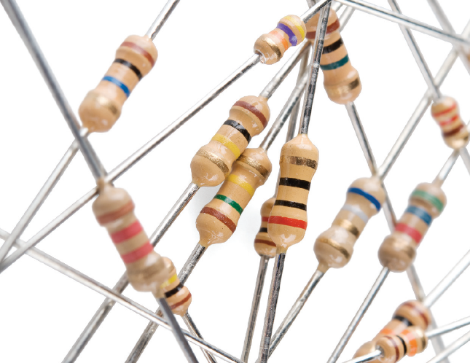

Resistors are electronic components that reduce the flow of electrical current. They are used to:

1. Limit current: Prevent excessive current from damaging components.

2. Divide voltage: Split voltage levels between components.

3. Impedance matching: Match the impedance of different components.

Types of resistors:

1. Fixed resistors: Have a fixed resistance value.

2. Variable resistors: Allow adjustable resistance values (potentiometers).

3. Power resistors: High-wattage resistors for heavy loads.

Characteristics:

1. Resistance value (ohms, Ω)

2. Tolerance (accuracy, ±%)

3. Power rating (watts, W)

4. Temperature coefficient (change in resistance with temperature)

Resistor color codes:

1. 4-band code: Resistance value and tolerance.

2. 5-band code: Resistance value, tolerance, and temperature coefficient.

Resistors are essential in electronic circuits, and understanding their properties and applications is crucial for designing and building electronic projects.

1. **Buzzers**

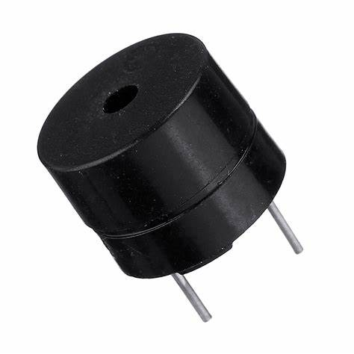

Buzzers are electronic components that produce a sound or alert when an electric current flows through them. Here are some key points about buzzers:

Types of buzzers:

1. Piezoelectric buzzers: Use piezoelectric materials to produce sound.

2. Electromagnetic buzzers: Use a magnetic coil and diaphragm to produce sound.

3. Active buzzers: Have a built-in oscillator and driver circuit.

4. Passive buzzers: Require an external oscillator and driver circuit.

Characteristics:

1. Frequency: Range of sound frequencies produced (e.g., 1-5 kHz).

2. Volume: Loudness of the sound produced (measured in decibels, dB).

3. Power consumption: Current and voltage requirements.

4. Operating voltage: Range of voltages that can be applied.

Applications:

1. Alarms and alerts

2. Timers and reminders

3. Notifications and warnings

4. Games and toys

5. Medical devices

6. Industrial control systems

**5.2 Software Requirements:**

Arduino IDE

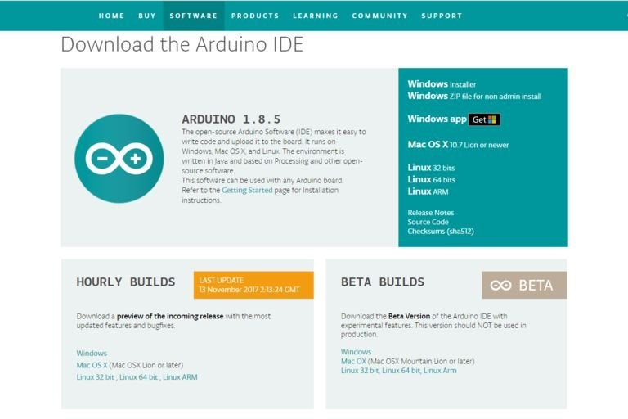

About Arduino IDE

* 1. Open-source: The Arduino IDE is free and open-source, allowing users to modify and distribute the software.
  2. Cross-platform: The IDE is available for Windows, macOS, and Linux operating systems.
  3. Programming language: The Arduino language is based on C/C++ and provides a simplified syntax for beginners.
  4. Code editor: The IDE features a code editor with syntax highlighting, auto-completion, and code refactoring.
  5. Library management: The IDE allows users to easily install and manage libraries for additional functionality.
  6. Board support: The IDE supports a wide range of Arduino boards and compatible devices.
  7. Serial monitor: The IDE includes a serial monitor for communication between the board and the computer.
  8. Debugging tools: The IDE provides debugging tools, such as breakpoints and serial output, to help troubleshoot code.
  9. Extensible: The IDE can be extended through plugins and custom boards.
  10. Community-driven: The Arduino community contributes to the development and maintenance of the IDE.

The Arduino IDE software provides a user-friendly and flexible environment for developing and deploying Arduino projects, making it a popular choice among hobbyists, students, and professionals.

**CHAPTER 6**

# IMPLEMENTATION

### METHODOLOGY

1. The Ultrasonic Sensor resembles a servo motor.
2. This sensor senses the signal it reﬂects to servo motor this UV sensor working voltage ranges from 2 to 5volts.
3. These signals are invisible to the naked eye.
4. However, we can see these the working with barrier attach to servo motor.
5. Ultrasonic sense the distance between car and barrier and signal goes to Arduino UNO.

1. Requirements Gathering:

* + 1. Identify the requirements for the barrier sensing module
    2. Determine the desired range and accuracy of the sensor
    3. Decide on the output format (LED indication, distance measurement, etc.)

2. Hardware Selection:

* + 1. Choose the Arduino board and Ultrasonic sensor (HC-SR04)
    2. Select the LED and resistor for indication
    3. Prepare the breadboard and jumper wires

3. Circuit Design:

1. Design the circuit diagram for the module
2. Connect the Ultrasonic sensor to the Arduino board
3. Add the LED and resistor for indication

4. Software Development:

* 1. Write the code for the barrier sensing module using Arduino IDE
  2. Implement the distance measurement algorithm
  3. Add LED indication logic

5. Testing and Debugging:

1. Test the module with various obstacles and distances
2. Debug the code and circuit as needed
3. Verify the accuracy and range of the sensor

6. Integration and Deployment:

* 1. Integrate the module with other systems (e.g., robotics, automation)
  2. Deploy the module in the desired environment
  3. Monitor and maintain the module as needed
  4. **CODE**

// defines pins numbers

const int trigPin = 13;

const int echoPin = 12;

const int buzzer = 11;

const int ledPin = 10;

// defines variables

long duration;

int distance;

int safetyDistance;

void setup() {

pinMode(trigPin, OUTPUT); // Sets the trigPin as an Output

pinMode(echoPin, INPUT); // Sets the echoPin as an Input

pinMode(buzzer, OUTPUT);

pinMode(ledPin, OUTPUT);

Serial.begin(9600); // Starts the serial communication

}

void loop() {

// Clears the trigPin

digitalWrite(trigPin, LOW);

delayMicroseconds(2);

// Sets the trigPin on HIGH state for 10 micro seconds

digitalWrite(trigPin, HIGH);

delayMicroseconds(10);

digitalWrite(trigPin, LOW);

// Reads the echoPin, returns the sound wave travel time in microseconds

duration = pulseIn(echoPin, HIGH);

// Calculating the distance

distance= duration*0.034/2;

safetyDistance = distance;

if (safetyDistance <= 80) // You can change safe distance from here changing value Ex. 20 , 40 , 60 , 80 , 100, all in cm

{

digitalWrite(buzzer, HIGH);

digitalWrite(ledPin, HIGH);

}

else{

digitalWrite(buzzer, LOW);

digitalWrite(ledPin, LOW);

}

// Prints the distance on the Serial Monitor

Serial.print("Distance: ");

Serial.println(distance);

}

**CHAPTER 7**

# RESULTS

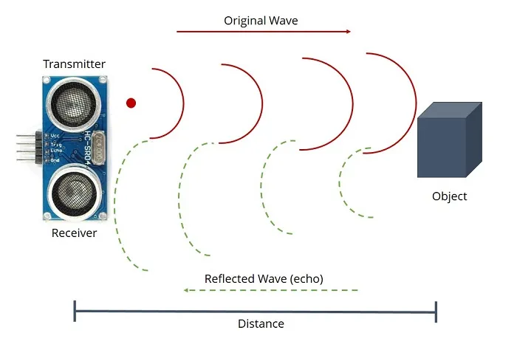

Fig.7.1

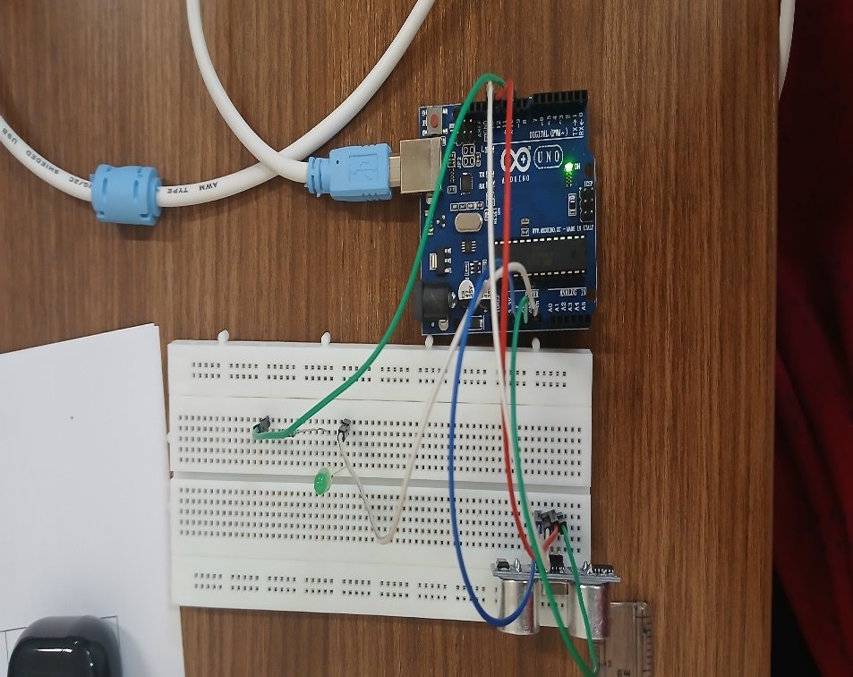

Fig.7.2

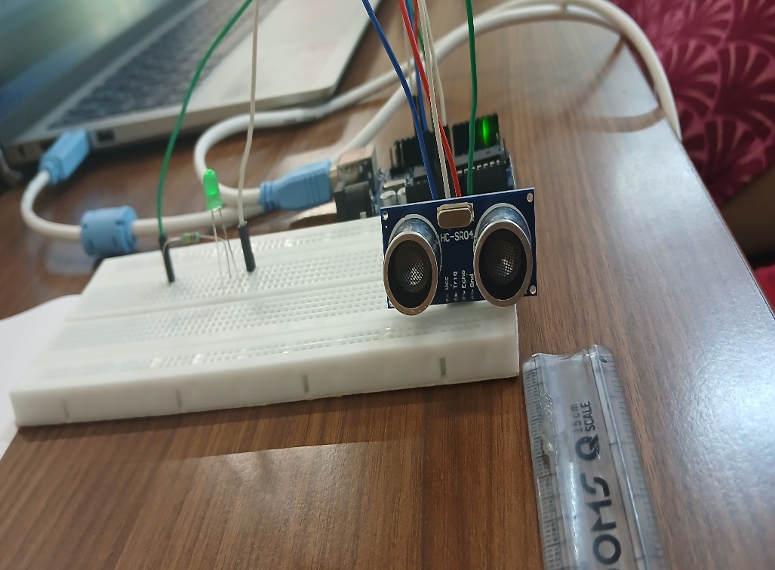

Fig.7.3

**CHAPTER 8**

# APPLICATIONS

1. Robotics: Obstacle detection and avoidance for autonomous robots.
2. 2. Industrial Automation: Detecting objects on conveyor belts or in storage facilities.
3. Home Automation: Detecting obstacles for smart home systems, such as vacuum cleaners or security systems.
4. 4.Accessibility: Assisting visually impaired individuals with obstacle detection.
5. Security Systems: Intruder detection and alert systems.
6. Parking Sensors: Detecting obstacles for parking assistance systems.
7. Drone Obstacle Avoidance: Detecting obstacles for drones and UAVs.
8. Smart Cane for Visually Impaired: Integrating the module into a smart cane for obstacle detection.
9. Automated Guided Vehicles (AGVs): Obstacle detection for AGVs in warehouses or factories.
10. 10.Medical Devices: Detecting obstacles for medical devices, such as wheelchairs or hospital equipment.
11. 11.Agricultural Automation: Detecting obstacles for autonomous farming equipment.
12. 12.Smart Wheelchairs: Integrating the module into smart wheelchairs for obstacle detection.

**CHAPTER 9**

**ADVANTAGES AND DISADVANTAGES**

**Advantages:**

The technology used by ultrasonic sensors is non-contacting, this gives the sensors most of the advantages they have.

1. Non-Contact Sensing: Detects obstacles without physical contact, reducing wear and tear.
2. Easy Integration: Compatible with various Arduino boards and sensors, making it easy to integrate into projects.
3. Adjustable Range: Adjustable detection range (20 cm to 400 cm) to suit different applications.
4. Low Cost: Affordable and cost-effective solution for obstacle detection.
5. High Accuracy: Accurate distance measurement (± 1 cm) for reliable obstacle detection.
6. Fast Response Time: Quick response time (< 50 ms) for timely obstacle detection.

**Disadvantages:**

1. Limited Range: Maximum detection range of 400 cm, which may not be sufficient for some applications.
2. Interference: Ultrasonic sensor can be affected by electromagnetic interference (EMI) or other ultrasonic sources.
3. Noise Sensitivity: Sensor can be sensitive to noise, which may affect accuracy.
4. Angle Dependence: Sensor accuracy can be affected by the angle of the object.
5. Temperature Dependence: Sensor accuracy can be affected by extreme temperatures.
6. 6.Humidity Dependence: Sensor accuracy can be affected by high humidity.

# CONCLUSION

As the main goal of this project, the Arduino Barrier Sensing Module is a versatile and cost-effective solution for obstacle detection in various applications. Its advantages, such as non-contact sensing, easy integration, adjustable range, and low power consumption, make it an attractive option for developers and makers. While it has some limitations, such as limited range and interference sensitivity, these can be addressed through proper design and implementation.

The module's potential applications in robotics, industrial automation, home automation, accessibility, and security systems demonstrate its broad range of uses. Future developments, such as improved range and accuracy, multi-object detection, and integration with AI and machine learning, will further enhance its capabilities.

Overall, the Arduino Barrier Sensing Module is a valuable tool for anyone looking to implement barrier detection in their projects, and its future scope is vast and exciting.

# FUTURE ASPECTS

1. 1.Improved Range and Accuracy: Enhancing the detection range and accuracy of the module.
2. 2.Multi-Object Detection: Enabling the module to detect multiple objects simultaneously.
3. 3.Advanced Signal Processing: Implementing advanced signal processing algorithms for better noise reduction and interference rejection.
4. 4.Integration with AI and Machine Learning: Integrating the module with AI and machine learning algorithms for predictive analytics and decision-making.
5. 5.Wireless Connectivity: Adding wireless connectivity options (e.g., Wi-Fi, Bluetooth) for remote monitoring and control.
6. 6.Miniaturization: Reducing the size of the module for easier integration into smaller devices.
7. 7.Increased Robustness: Enhancing the module's robustness and reliability in harsh environments.
8. 8.Multi-Sensor Fusion: Integrating the module with other sensors (e.g., cameras, lidar) for enhanced detection capabilities.
9. 9. Autonomous Systems: Using the module in autonomous systems, such as self-driving cars or drones.
10. 10.IoT Integration: Integrating the module with IoT platforms for real-time monitoring and control.
11. 11.Advanced Materials Detection: Enabling the module to detect specific materials or objects.
12. 12.Medical Applications: Exploring medical applications, such as prosthetic limb control or medical device navigation.

# REFERENCES

1. https://www.researchgate.net/publication/373989098_Traffic_Barrier_Distance_Controller_Using_Ultrasonic_Sensors_Based_on_Arduino_Uno
2. https://www.aranacorp.com/building-an-automatic-barrier/
3. https://forum.arduino.cc/t/simple-ir-barrier-sensor-for-arduino/68868
4. https://marobotic.com/2023/11/17/automatic-smart-car-barrier-system-using-arduino/

[5] https://circuitdigest.com/microcontroller-projects/interfacing-ir-sensor-module-with-arduino

[6] https://www.hackster.io/embeddedlab786/automatic-smart-car-barrier-system-950b08

[7] https://www.arduino.cc/en/software/

[8] https://youtu.be/aE_J7B-O4VQ?si=dfl0kH-Z6BLi7TG4

[9] https://youtu.be/KGwtit2bFyo?si=ZRt3R3y9cIyO6Orz